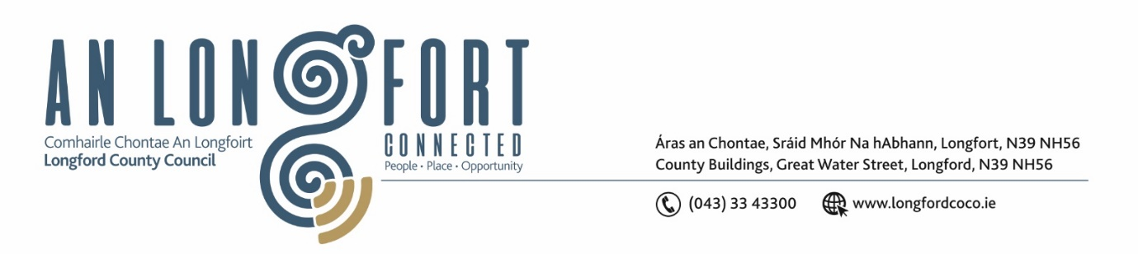

***Please note meeting will be held in the Council Chamber and via Microsoft Teams.***

4ú Samhain 2021.

**Chuig: Gach Ball don Chomhairle.**

A Chomhairleoir,

Iarrtar ort bheith i láthair ag Cruinniú Míosuil Chomhairle Chontae Longfoirt a tionólfar i Seomra na Comhairle, Aras an Chontae, Longford agus via MS Teams are an **Chéadaoin, 10ú Samhain 2021 ag** **3.00pm** chun gnó a dhéanamh d’réir an Chláir thíos.

You are requested to attend the Monthly Meeting of Longford County Council to be held **in the Council Chamber, Aras an Chontae and** **via Microsoft Teams** on **Wednesday, 10th November 2021 at 3.00pm** to transact business, as set out on the Agenda hereunder.

Mise le meas,

*Ann Marie Mc Keon*

**__________________**

**Ann Marie Mc Keon**

**Meetings Administrator.**

**C L Á R**

Prayer before meeting.

1. Confirmation of Minutes
2. Monthly Meeting of Longford County Council held on 13th October 2021 –

copy enclosed.

(ii) Minutes of Committee Meeting of Longford County Council held on 13th

October 2021 – copy enclosed.

1. Matters Arising.
2. Declaration of Interest by Members.
3. To note Management Report – to follow.

**5.** To note adopted Minutes of Corporate Policy Group Meeting held on the

7th September 2021 – enclosed.

**6. Strategic Infrastructure, Regeneration and Climate Change**

**(a)** To note Planning Applications received since last meeting of the Council.

**(b)** To note adopted minutes of meeting of Climate Action and Planning Strategic Policy Committee held on the 21st July 2021 – enclosed.

**(c)** To note adopted minutes of meeting of Strategic Infrastructure Strategic Policy Committee held on the 29th July 2021 – enclosed.

**(d)** Items referred from Climate Action and Planning Strategic Policy Committee Meeting held on the 20th October 2021 –

* Derelict Sites Policy – enclosed.
* Dog Pound Fees – enclosed.

**(e)** Consideration of the disposal of Freehold Interest at 3 St. Patrick’s Terrace, Longford accordance with the terms of Section 183 of the Local Government Act 2001 issued on the 4th October 2021.

**7. Finance**

**(a)** To note adopted Minutes of meeting of Governance Strategic Policy

Committee held on the 26th July 2021 – enclosed.

**(b)** Consideration of Overdraft Accommodation of €15m for year ending 31st December 2022.

**(c)** NBI (National Broadband Ireland) update.

**8. Community, Corporate and Enterprise**

**(a)** To note adopted minutes of meeting of Placemaking Strategic Policy

Committee held on the 19th July 2021 - enclosed.

**(b)** Item referred from Placemaking Strategic Policy Committee Meeting held on the

18th October 2021 –

* Longford County Council Library Development Plan 2021-2025 – enclosed.

**(c)** Consideration of amendments to Longford County Council Standing Orders – enclosed.

**(d)** Consideration to approve grant under the 2021 Intercultural Grants Scheme – enclosed.

**9. General**

Notices of Motions, submitted by Councillors, as listed hereunder –

**Councillor Garry Murtagh**

Calling on elected members of Longford County Council to write to the Minister of Health Stephen Donnelly, in relation to insufficient support through the HSE for Home Help. To look within his budget to provided adequate and additional supports for this essential but pressurised service which is at breaking point. Private operators are failing to prop up this system due to min wage and zero subsidies for travel which is absolutely devastating rural Ireland, blocking up hospital beds and forcing people into nursing homes, were its not financially viable for them or the state.  In order to provide the care that is required.

**10. Correspondence**

**(i)** Correspondence dated 13th October 2021 received from An Garda Siochana

- Reply to Notice of Motion submitted by Councillor Uruemu Adejinmi – enclosed.

**(ii)** Correspondence dated 12th October 2021 received from the Department of Education - Reply to Notice of Motion submitted by Councillor Uruemu Adejinmi – enclosed.

**11. Votes of Sympathy**